ICE CREAM CALCULATOR
Documentation
V1.15
30 August 2021
Table of contents
1 Introduction 7
2 Overview 8
2.1 Create a recipe 8
2.2 green cells 8
2.3 yellow cells 8
2.4 ingredient 8
2.5 weight 9
2.6 w% 9
2.7 total (g) and total % 9
2.8 weight mode 9
2.8.1 Ingredient 9
2.8.2 Lock total weight 9
2.8.3 Scale 9
2.9 Final mix 9
2.10 Evaporation 9
2.11 Stabilizer +/- 9
2.12 Compare 10
2.12.1 View 10
3 Table 11
3.1 Add ingredient 11
3.2 Replace 11
3.3 Remove 11
3.4 Clear 11
3.5 Move up 11
3.6 Move down 11
3.7 Edit ingredient 11
3.8 Add-ins 11
3.9 Notes 12
3.10 Profile 12
3.11 Undo 12
3.12 Redo 13
3.13 Short-Keys 13
4 Recipe 14
4.1 Overview 14
4.2 New 14
4.3 Open 14
4.4 Merge 14
4.5 Save 14
4.6 Save all 15
4.7 Save as 15
4.8 Adding ingredients 15
4.9 Replace ingredients 15
4.10 Delete ingredient 15
4.11 Clear all ingredients 15
4.12 Modify an ingredient 15
4.13 Sorting 15
4.14 Weight and Rescale 15
4.15 Volume converter 16
4.16 Tabs 17
4.17 Save as Ingredient 17
4.18 Merge Ingredients 17
5 Chart 18
5.1 Overview 18
5.2 Customize 18
5.2.1 Min and Max 19
5.3 Detailed View 19
6 Data panels 20
6.1 Customize 20
6.2 Add panel 21
6.3 Default 21
6.4 Clear 21
7 Freezing Curve 22
8 Database 23
8.1 Overview 23
8.2 Filtering and searching 23
8.3 Edit ingredient 23
8.4 Customize 24
8.5 Category 25
8.6 Add ingredient 25
8.6.1 Add New 25
8.6.2 Add Copy 25
8.6.3 USDA Database 25
8.6.4 Nutrient Label 27
8.7 Remove ingredient 28
8.8 Handle Allergens 28
8.9 Handle Ingredients 28
8.10 Excel 29
8.11 Print 29
8.12 Import 29
9 Ingredient 31
9.1 Overview 31
9.2 Category 31
9.3 Ingredients/Allergens 32
9.4 Notes 32
9.5 Tools 32
9.5.1 Clear 32
9.5.2 Nutrients 32
9.5.3 USDA 32
9.5.4 Dairy 32
9.5.5 MSNF 32
9.5.6 HF 32
9.5.7 PAC/POD 32
9.5.8 Energy 33
9.5.9 Alcohol 33
9.5.10 Check 33
9.5.11 Chocolate 33
9.5.12 Verified 33
9.6 Data 34
9.6.1 Water 34
9.6.2 Total solids 34
9.6.3 Other solids 34
9.6.4 Cocoa solids 34
9.6.5 MSNF 34
9.6.6 Total fat 34
9.6.7 Saturated fat 34
9.6.8 Trans fat 34
9.6.9 Milk fat 34
9.6.10 Cocoa fat 34
9.6.11 Total carbohydrate 34
9.6.12 Dietary fiber 34
9.6.13 Total sugars 34
9.6.14 Nutrient label sugar 34
9.6.15 Added sugars 35
9.6.16 Lactose 35
9.6.17 Sugar alcohols 35
9.6.18 Protein 35
9.6.19 Salt 35
9.6.20 Alcohol 35
9.6.21 Stabilizer/Emulsifier 35
9.6.22 Energy 35
9.6.23 Cholesterol 35
9.6.24 Sodium 35
9.6.25 Vitamin D 35
9.6.26 Calcium 35
9.6.27 Iron 35
9.6.28 Potassium 35
9.6.29 Gram per mL 35
9.6.30 PAC 35
9.6.31 POD 35
9.6.32 HF 36
9.6.33 Cost 36
9.6.34 Print 36
10 Balance 37
11 Share 39
12 Nutrient Labels 40
12.1 Overview 40
12.2 Recipe Groups 40
12.3 Settings 40
12.4 Template 40
12.5 Generate 40
12.6 html 40
13 printing 41
14 milk/cream 42
15 overrun 43
16 Settings 44
17 Customization 46
18 Nutrients and calculated data fields 47
19 Science 49
19.1 Overview 49
19.2 PAC 49
19.3 POD 49
19.4 Freezing Point 49
19.5 Hardening Factor 49
19.6 Freezing Curve 49
19.7 Sugars 49
19.8 Stabilizers 51
20 System Requirements 54
21 Installation 54
22 References 55

Introduction
Ice Cream Calculator is a free Windows software to create, analyze and balance ice cream, sorbet and gelato recipes. When developing your own ice cream there are a number of variables to keep track of. Ice Cream Calculator automatically calculates all these variables, properties and ratios for you. Ice Cream Calculator keeps track of fat, solids, water, msnf, sugar and much more and makes is easy to create new recipes or modify existing recipes. Ice Cream Calculator also calculates sweetness and hardness of your ice cream.
Ice Cream Calculator is also a place where you can collect and manage all your recipes. You have access to a large database of ingredients and recipes. You can store your own ingredients and recipes locally or online.
Ice Cream Calculator does not have to be used for ice cream, it can be used for all types of recipes where you need to control and keep track of nutrients and water, fat, solids etc. For example, praline and ganache recipes. Many of the features in Ice Cream Calculator have been specifically developed for praline creation.
If you work professionally Ice Cream Calculator can keep track of ingredients and allergy information and lets you create ingredient lists and nutrition labels.
Ice Cream Calculator can be used in different ways depending on your goals. You can use it as a simple recipe database or you can use it to develop, calculate and analyze recipes in great detail.
Features
- Balancing
- Calculates all ice cream related parameters and ratios
- Standard and user ingredient database locally or online
- Recipe handling
- Create ingredient from a recipe
- Merge recipes
- Multiple tools for scaling recipes
- Freezing point and freezing curve calculations and serving temp estimation
- Handles add-ins
- Handles evaporation
- Track nutrients
- Nutrient labels and ingredient list with allergy information
- Multiple ways to add ingredients. USDA database, from nutrient labels or manually.
- Overrun calculations
- Fully customizable
- Printing
- Notes
- Milk and Cream tool handles milk and cream with different fat%
- Compare recipes
- Users can share recipes and ingredients in the online database
- Totally free even for commercial use
- Volume to weight converter to be able to add recipes written with volume units

Overview
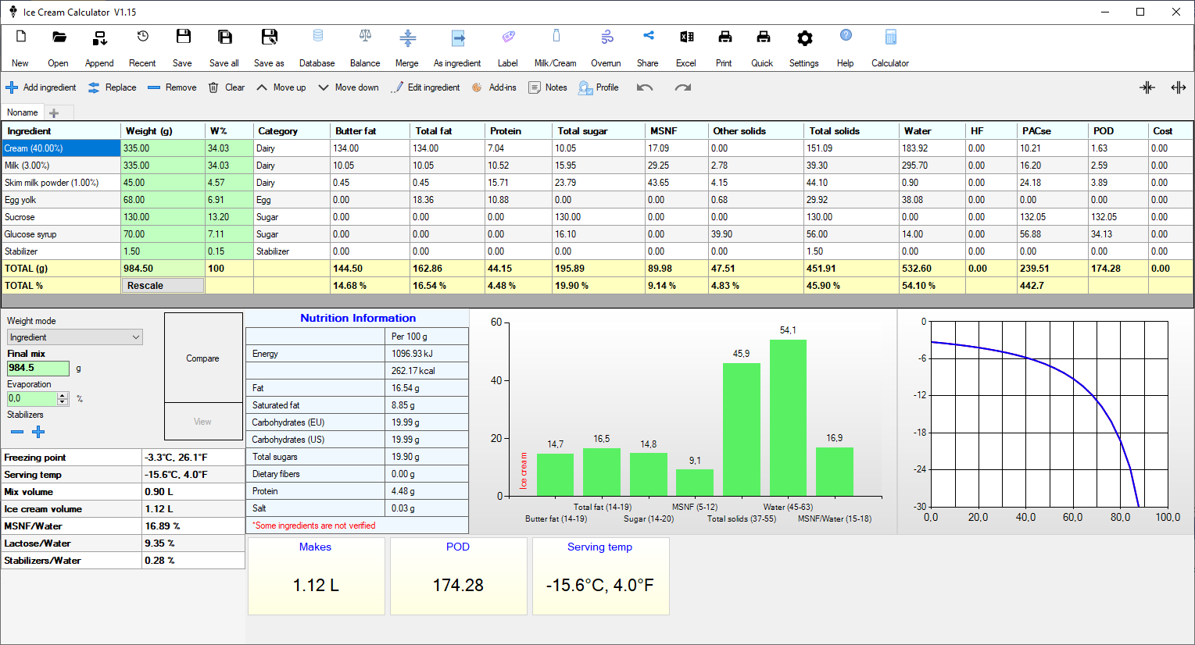
At the top are open/save buttons and different tools and settings. Then we have the main ingredient list. At the bottom we have all the resulting calculations.

Create a recipe
Let’s start by creating a simple recipe.
- Press the New button to start a new recipe
- Now we will add the ingredients
- Press the “+” button above the list. This will open up the ingredient database.
- Find Milk in the list and press OK to add it to the recipe
- Repeat this with all the ingredients
- Now, for each ingredient in the list enter the correct weight.
- As you start setting the weight of each ingredient you will see the numbers in the table and chart changing.
- Done.

green cells
Green cells can be changed by the user

yellow cells
Yellow cells are generally calculated values

ingredient
Name of the ingredient used in a recipe

weight
Weight in grams. If you change the Weight in the Total row all the ingredients will be scaled. This means you can easily scale up or down the size of the recipe.

w%
Weight in % of total weight. Note! When Weight Mode is set to Scale and changing the W% it will work the same as when set to Ingredient.

total (g) and total %
Summary of total weight and total percentage.

weight mode
When changing the weight for an ingredient the software can adjust the total recipe in different ways.

Ingredient
Only the selected ingredients weight is changed. This is the default mode. This means if you change the weight of one ingredient the total weight will also change accordingly.

Lock total weight
The selected ingredient will change and all other ingredients will be scaled to keep the total weight constant. The other ingredients are scaled proportionally to make sure the total weight is the same.

Scale
The selected ingredient will change and all other ingredients will be scaled to keep the recipe balance identical. This is convenient if you don’t have enough of one ingredient to make your recipe. You can enter the amount you have and all the other ingredients will be scaled to keep all the ratios the same.

Final mix
Total weight of the mix minus the water evaporation from cooking.

Evaporation
Water evaporation from cooking the mix. When cooking the mix water will evaporate and reduce the amount of free water. You can account for this in the calculations. In the table Water, PAC and POD as well as TOTAL% are affected by the evaporation and the final mix weight. When cooking on the stove in the traditional way you will have approximately 2%-5% evaporation. This is also very useful when cooking other recipes like caramel where you have a lot more evaporation.

Stabilizer +/-
This will increase/decrease the weight of all stabilizer ingredients. This makes it easier to fine tune the amount of stabilizers in the recipe.

Compare
This will “lock” the current recipe in the chart and freezing curve. Changing the recipe or changing tab allows you to compare the locked recipe with another recipe.

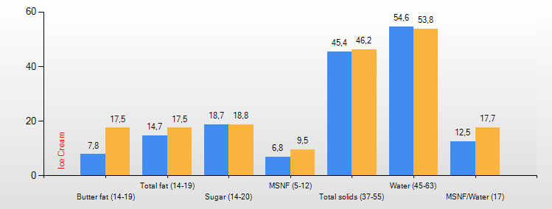

View
Pressing View will bring up a compare list that compares the current recipe with the compare recipe.
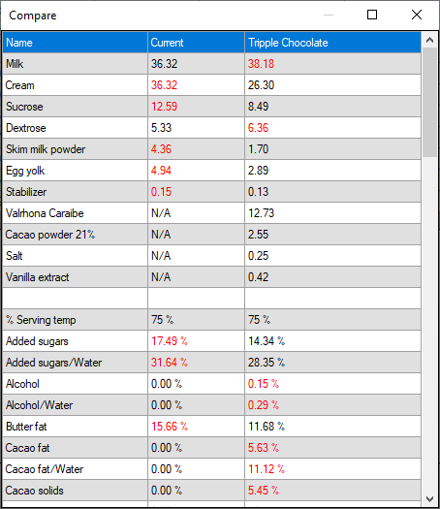

Table
This is the main table with all the ingredients listed and two summary rows at the bottom.
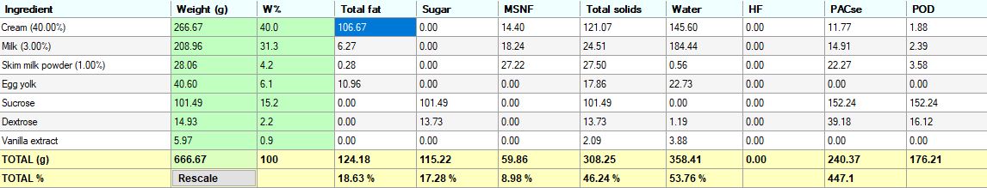
The table can be customized by right clicking in the table. The first three columns are fixed and cannot be turned off. More on customizations later.
Compacts and Expands the columns in the table.

Add ingredient
Opens up the ingredient database dialog where you can select one or multiple ingredients to add.

Replace
Opens the ingredient database dialog where you can select one ingredient to replace the current ingredient. The weight will be the same.

Remove
Removes the selected ingredient

Clear
Clears all ingredients

Move up
Moves the selected ingredient one step up

Move down
Moves the selected ingredient one step down

Edit ingredient
Edits the selected ingredient. You can also double-click in the name cell to edit.

Add-ins
Manage add-ins. Add-ins are ingredients that are part of the recipe but is added after or at the end of churning. These add-ins will not affect the calculations of freezing points, serving temperature or evaporation etc. Note! If you want to create accurate nutrition labels that includes add-ins you cannot use this feature. You have to create sub-recipes and merge them in the label creation. More info on this in the label chapter.
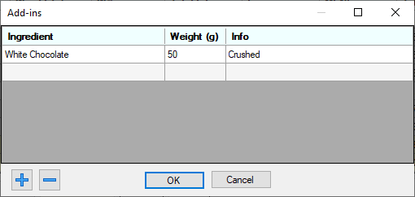
You can press the + button to select an ingredient from the database or just type directly in the grid.

Notes
Here you can add notes to your recipe. If there are notes the button will be green to indicate this.
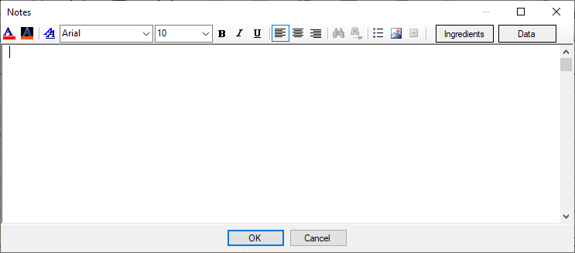
The Ingredients and Data buttons will insert your ingredients and data into the editor.

Profile
Profile will save the current Chart, Panels, Data, Serving temp% and Overrun% to the recipe. This means that if you have multiple tabs open each recipe can have its own chart and panels. For example you have one tab with an ice cream and one tab with a gelato you can show the ice cream chart for the ice cream and the gelato chart for the gelato. This setting is also saved with the recipe.

Undo
Undo will undo any weight changes you make on the ingredients. It is not a full undo of the whole system, just weight changes.

Redo
Redo the last weight change

Short-Keys
- CTRL+S Save
- CTRL+Z Undo
- CTRL+Y Redo
- CTRL+N New
- CTRL+O Open
- CTRL+P Print
- CTRL+W Close tab

Recipe

Overview
A recipe is the list of ingredients, notes and add-ins.

New
Start a new recipe in the current tab.
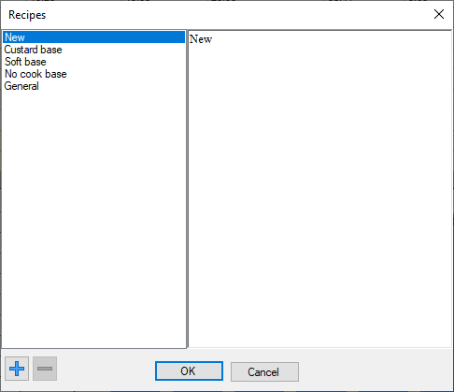
When pressing new this dialog will open and you can select from a blank New recipe or from a list of basic standard recipes. You can also add your own recipes to this list by using the + button. This way you can add your favorite bases to start from.

Open
Just opens a recipe file.
When opening a recipe, the ingredients in that recipe is checked against the database and the ingredient is automatically updated. If the ingredient is not found in the database it is automatically added to the database.

Merge
Merging is a way to add a recipe to the current recipe. You select a recipe file and are prompted to select the weight of that recipe. Then all ingredients in the selected recipe is added to the current recipe. This is very useful if you have for example created recipe files with fruit purees that you want to add to your current recipe.

Save
Saves the current recipe.

Save all
Saves all the recipes if you have multiple tabs.

Save as
Saves the current recipe with another name.

Adding ingredients
To add an ingredient, press the button above the table. This will show the ingredient database dialog and you can select one or multiple ingredients to add.

Replace ingredients
To replace an ingredient, press the replace button . This will show the ingredient database dialog where you can select a replacement. The weight will not change.

Delete ingredient
Just press the delete button .

Clear all ingredients
Press the clear button to remove all ingredients.

Modify an ingredient
To edit an ingredient double click in the ingredient cell or press the edit button . You cannot edit ingredients in the standard online database. If this is the case you will be prompted to make a copy to your local database.

Sorting
You can sort your ingredients by clicking the column headers. You can also use the up/down buttons to move an ingredient up or down.

Weight and Rescale
Changing the TOTAL weight cell will rescale the whole recipe to this weight.
Pressing the Rescale button brings up the rescale tool where you have more control of the weights.
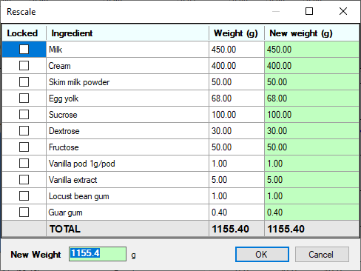
Here you can rescale the recipe with more control compared to the main dialog.
You can lock ingredients by checking the Locked checkbox. If an ingredient is locked it will not change its weight when you enter a new weight. You can either change the new total weight or you can change the individual weights. All ingredients that are not locked will be rescaled to the new weight.
If you enter a value in the New Weight edit then all non-locked ingredients will rescale to fit the new weight.
If you change the weight in the green cells of the ingredients then all non-locked ingredients will rescale to fit the new weight and the ingredient you edited will have the value you entered.
It’s a powerful and flexible tool to modify the recipe and ingredient weights.

Volume converter
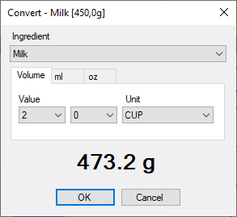
If you double-click in the weight cell of an ingredient the volume converter will open.
Here you can convert a volume measurement to weight in grams for some common ingredients. Supports tsp and tbsp for both US, Metric and Australia as well as ml and ounces. This is a convenient way to convert a volume-based recipe to weight.

Tabs
You can work with multiple recipes at the same time in different tabs.
To add a new tab press the “+” tab. To remove a tab right-click and select remove.
This is very handy when you want to compare recipes using the Compare tool.

Save as Ingredient
This is a very powerful feature. You can convert a recipe to an ingredient. You can for example make ice cream bases and save them as ingredients, this base can later be added to a new recipe. You can also use it for creating add-ins like caramel etc.

Merge Ingredients
If you happen to have multiple identical ingredients in your recipe you can use this function to merge these into one line in the table.

Chart
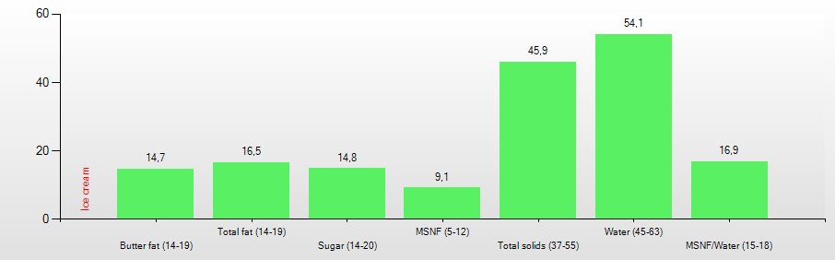

Overview
The chart shows calculated data from your current recipe.

Customize
If you right click in the chart a popup menu will open where you can select from a few standard and user defined charts.
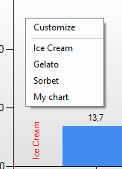
If you press Customize you can customize your charts.
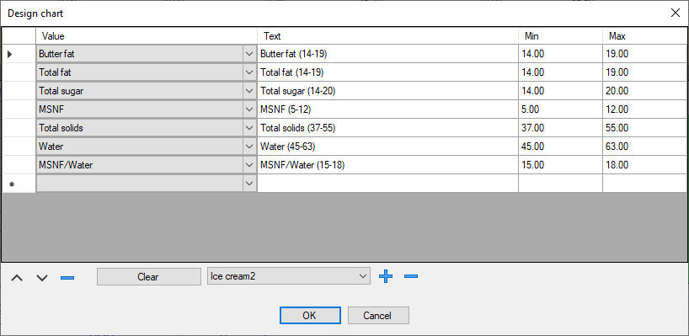
You can add and edit the data and the descriptions to create your own charts. You cannot modify the standard charts so you have to press the + button to add a user chart. This chart can then be modified.

Min and Max
You can also set Min and Max range values. If the value is inside the range the bar will be GREEN if the value is outside the range the bar will be RED. If no range is set the bar will be BLUE.

Detailed View
Double click in the chart to bring up a list of all calculated values.
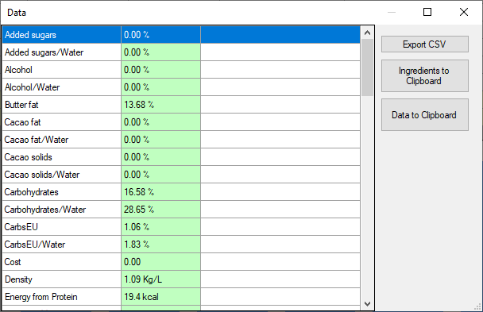
This list can also be copied to the clipboard or exported as a CSV file.

Data panels
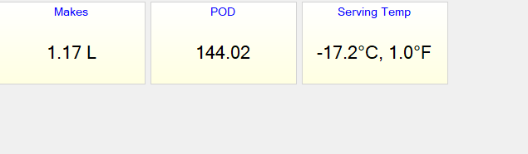
Below the chart area you can add panels with additional data. By right clicking in this area you can add/remove/customize the panels. By double clicking in a panel you can edit it.
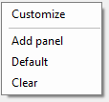

Customize
Save and load panel profiles.

Add panel
Select Add panel to add a new panel.
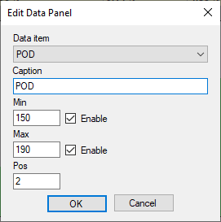
Here you select the data and caption to display and the position of the panel. You can also enable min and max values. If the value is inside the range the panel will be GREEN if it outside the range it will be RED. If no min or max is set the panel will be BLUE.

Default
Load the default panels

Clear
Removes all panels

Freezing Curve
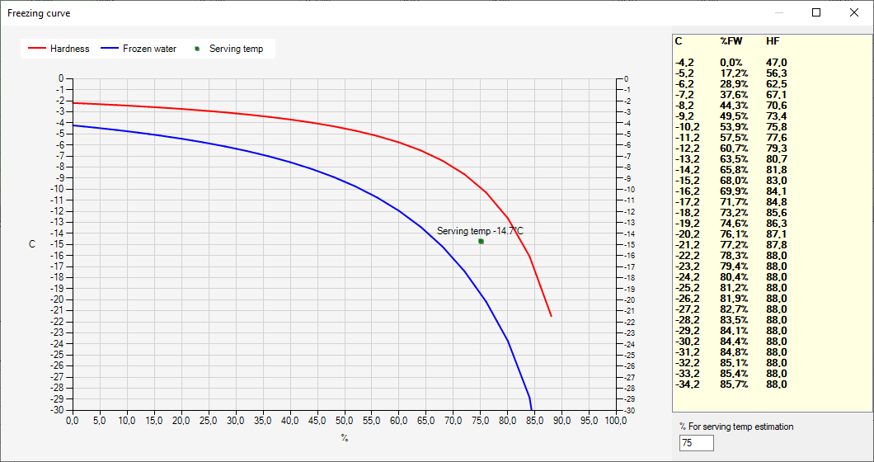Double-Click on the curve in the main window to bring up this dialog.
Shows the amount of frozen water and the hardness of the ice cream for different temperatures.
The blue curve shows the frozen water and the red curve the hardness.
The frozen water is calculated using the sugars, msnf, salt and alcohol in the recipe.
The hardness curve also uses the hardening factor value to simulate how hard the ice cream is.
These curves are calculated using a 4th order polynomial regression calculation using freezing point data of sucrose solutions.
The estimated serving temperature is calculated as the average between the freezing curve and the HF-curve at the “% For serving temp estimation” percentage. The default is 75%. This means that the serving temp is calculated for 75% frozen water. This value might need to be tweaked or changed depending on what type of ice cream you make. For example gelato might need 65-70% instead of 75% to show an accurate serving temp estimation.
Note! This is very much an approximation. The calculation of frozen water and hardness is very complicated. Use this as a rough guide and not as absolute truth.

Database
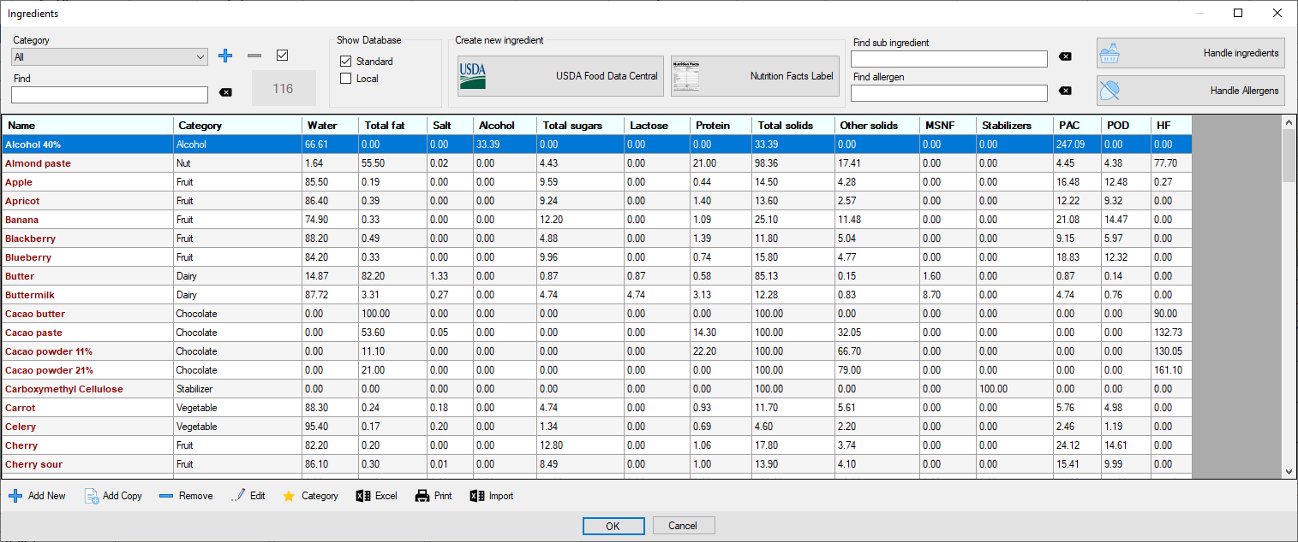

Overview
This is where you handle your ingredients.
The database is actually two databases. One is the standard online database that comes with the program and the second is your local user database. The local database is saved on disc in your data folder. You can open your data folder from the Settings in the main dialog if you need to for example backup your database. The file is located here: C:\ProgramData\Ice Cream Calculator\user.db
If you use Ice Cream Calculator professionally and use it to create nutrient labels and ingredient lists you should turn off the standard online database and only use your local database. This can also be done in the Settings. This is important because you need full control of your ingredients and be sure they are accurate for nutrition calculations.
The standard database contains 100+ ingredients to get you started.

Filtering and searching
At the top you have the category dropdown. Selecting a category will only show ingredients in that category. Below the category is the Find edit. Just type in this edit and the list will only show ingredients matching this. You can also turn on/off ingredients using the Show database checkboxes.
- Standard
  - Turn on/off standard online ingredients
- Local
  - Turn on/off local ingredients
You can also filter the list using the “Find sub ingredient” and “Find allergens” edits.

Edit ingredient
Double click on an ingredient or press the Edit button to edit an ingredient.

Customize
You can customize the table by right clicking on it.
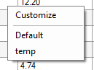
Selecting Customize will bring up the table customization dialog where you can customize what data to show in the table.
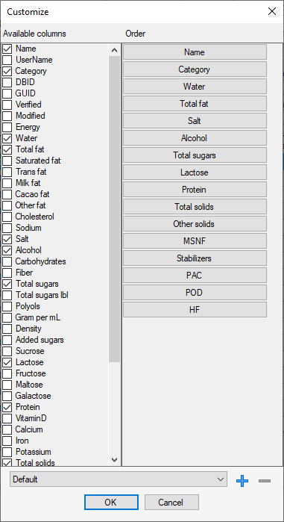

Category
Selecting a category in the category dropdown will filter the list. You can add and delete categories.
If you check the Default checkbox this category will be pre-selected when you add or replace ingredients from the main dialog.
You can also change category for multiple ingredients by clicking the Category button.
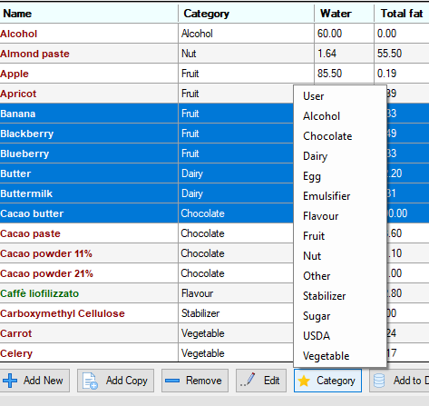

Add ingredient

Add New
Adds a new blank ingredient and you have to fill in all the data, see the ingredient chapter for more information.

Add Copy
This will copy the currently selected ingredient and make a copy of it.

USDA Database
One of the easiest ways to add a new ingredient is to use the USDA database.
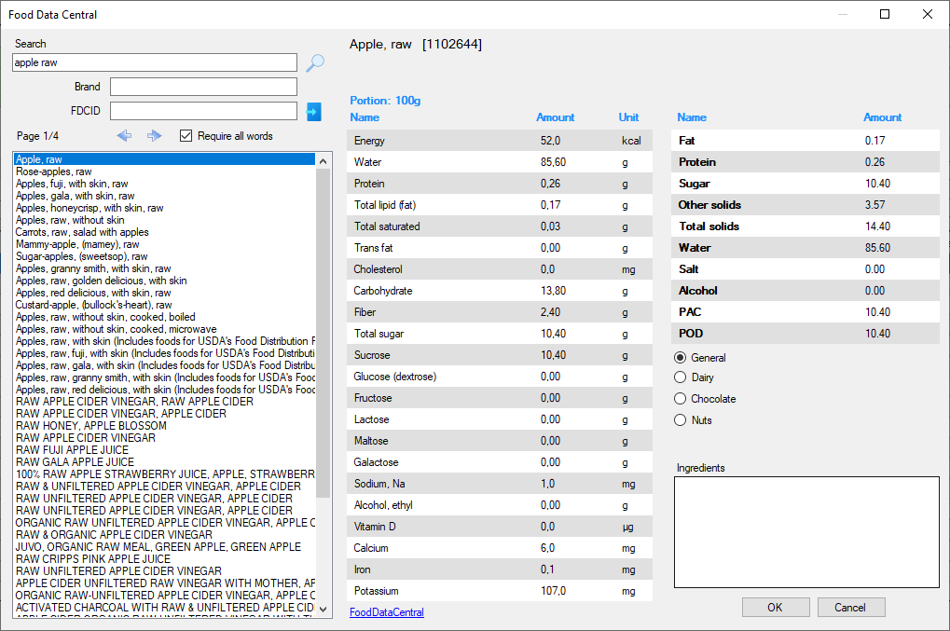
Here you can search for ingredients in the USDA database. You can also filter by brand and you can enter the USDA FDCID directly. This can be useful if you use the USDA website to search for an ingredient, then just type in the FDCID directly.
When adding you can select the type of ingredient in the radio buttons.
- General
  - Use for normal ingredients
- Dairy
  - Use for pure milk/cream products. This will automatically calculate MSNF and milk fat etc and set the Category to Dairy.
- Chocolate
  - Use for chocolate ingredients. This will automatically set the Cacao fat and Cacao solids and set the Category to Chocolate.
- Nuts
  - Use for nut pastes and nut butter. This will automatically set the Category to Nuts.
The Ingredients text box will show all sub-ingredients. These will be added to the ingredient. You can edit this text before pressing OK.
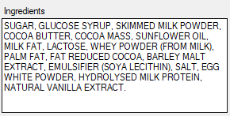

Nutrient Label
This will add a new ingredient using a nutrition label.
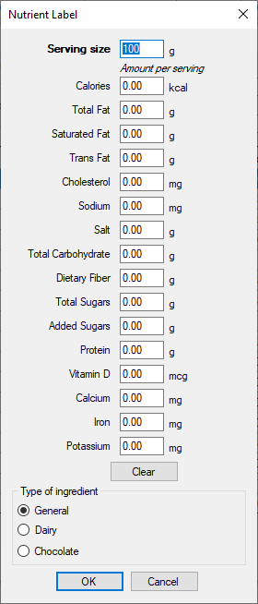
For EU users the Serving size is 100 and for US users you will find the Serving size on the label you want to copy.
Just fill in the data from the label you want to copy. Leave the value to 0 if it is not available. EU and US nutrient labels looks different but this list should cover both. The total carbohydrate should be added using the US rules that includes dietary fiber. In the EU the carbohydrates does not include fibers so you might need to correct for that.
When adding you can select the type of ingredient in the radio buttons. Note that type of ingredient is not the same as Category!
- General
  - Use for normal ingredients
- Dairy
  - Use for pure milk/cream products. This will automatically calculate MSNF and milk fat etc and set the Category to Dairy.
- Chocolate
  - Use for chocolate ingredients. This will automatically set the Cacao fat and Cacao solids and set the Category to Chocolate.

Remove ingredient
You will only be able to remove ingredients from your local database and ingredients in the online database that you have added yourself.

Handle Allergens
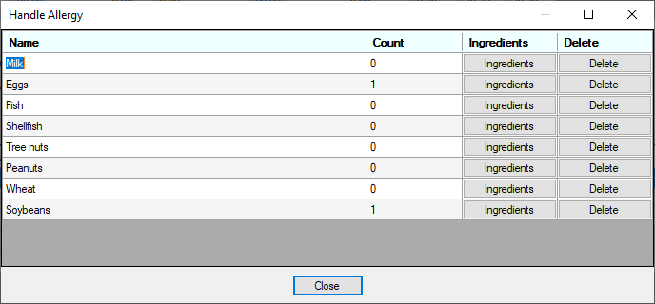
When using the nutrition label system, you need to track allergy information. Every ingredient has a list of allergies. This feature lets you handle all the ingredients allergy information in one place. You can add or delete allergy items and by pressing the Ingredients button you can see and edit the ingredients that have this allergy item.

Handle Ingredients
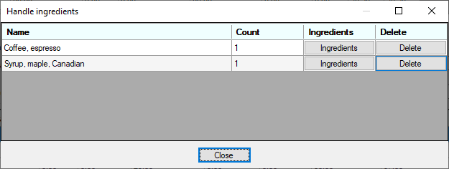
Similar to the Allergens dialog here you can handle all sub-ingredients in all your ingredients.

Excel
Exports the database to Excel

Print
Prints the visible rows in the list

Import
Bulk import of ingredients from Excel (or other spreadsheet data).
Workflow is like this.
- Mark up the data in your spreadsheet including the title row.
- Copy to clipboard
- Press the Paste button
- Map columns from your spreadsheet data to the calculator. You do this by double-clicking on the header for each column you want to import.
- Press PREVIEW to see the result
- Press OK to import
Example.
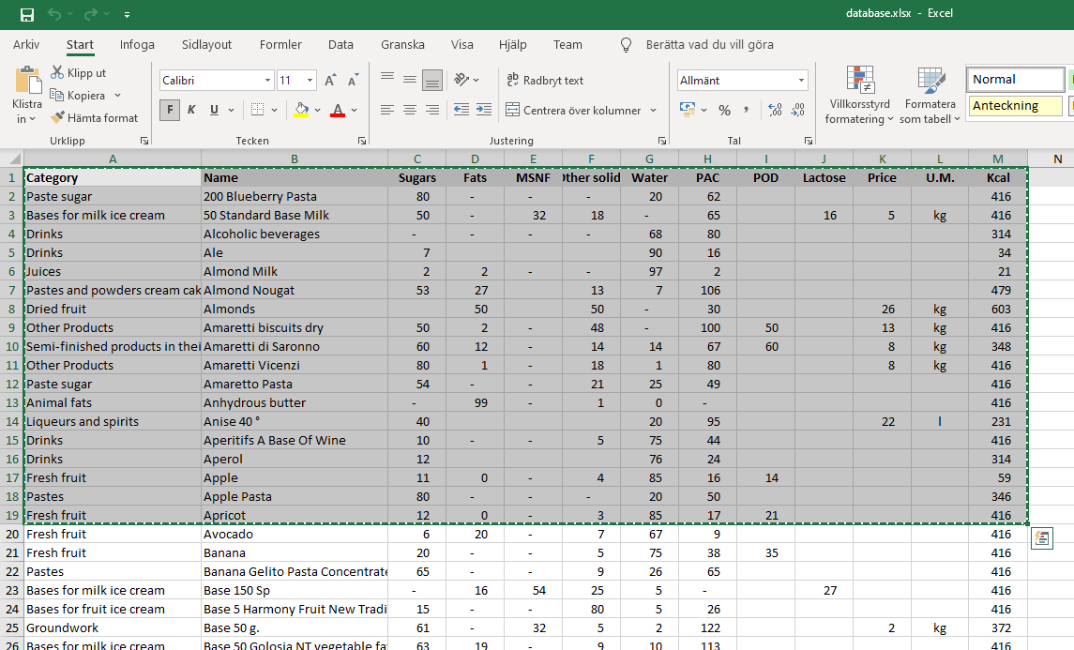
Copy from Excel
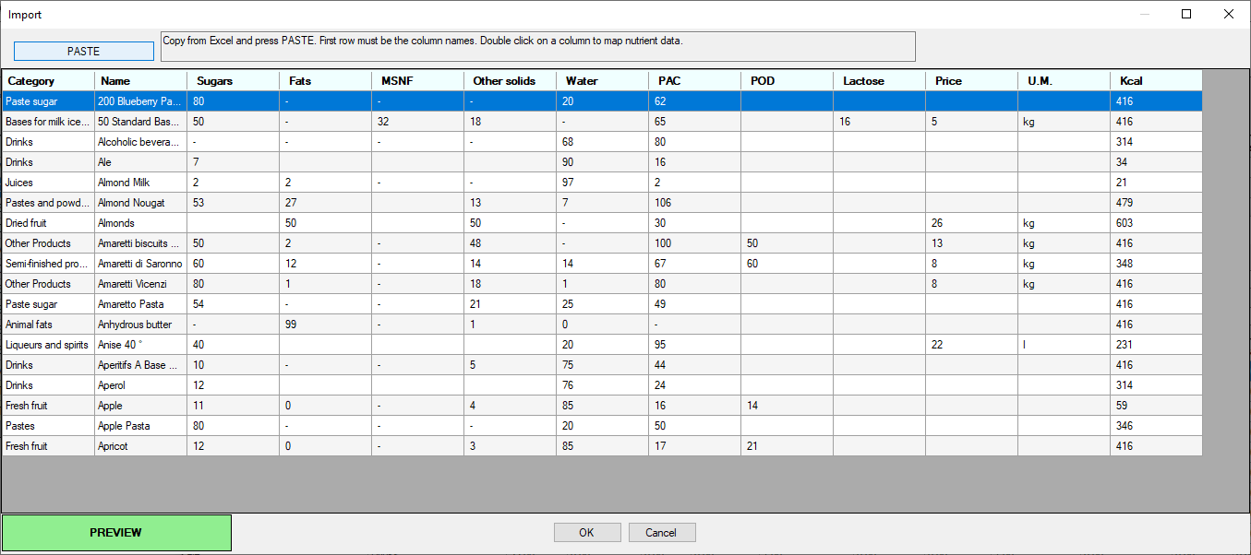
PASTE
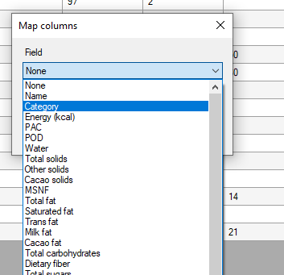
Map colums
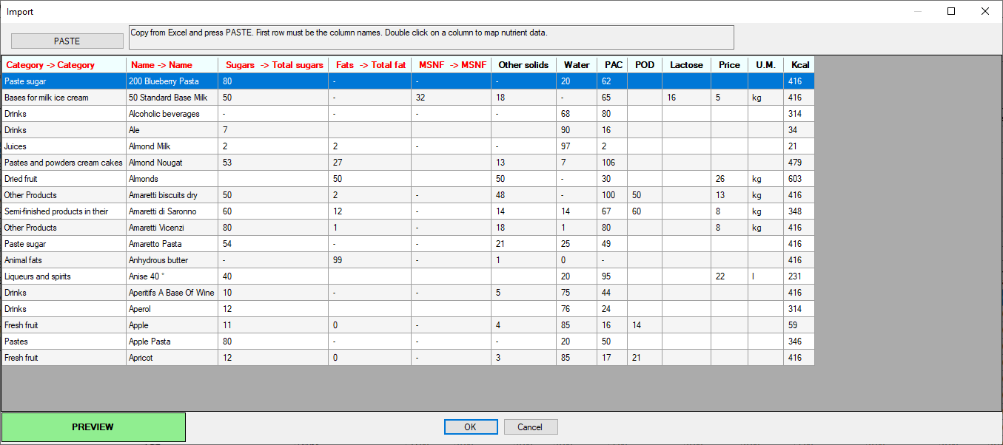
Mapping complete (not all columns will be imported in this case)
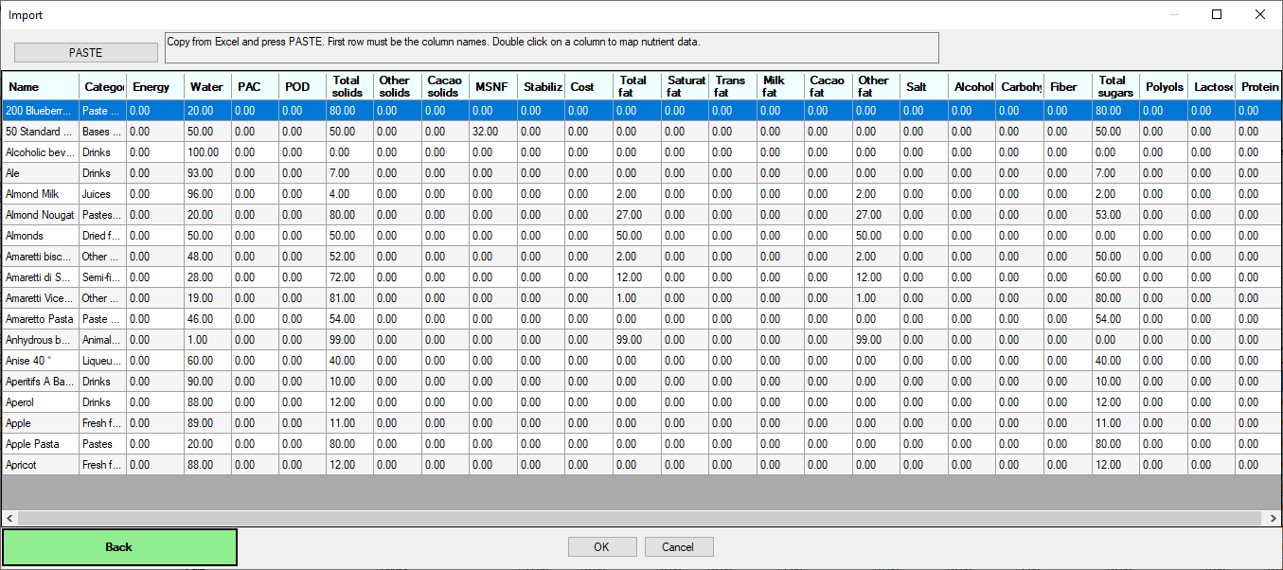
Preview
Now just press OK to import ingredients.

Ingredient
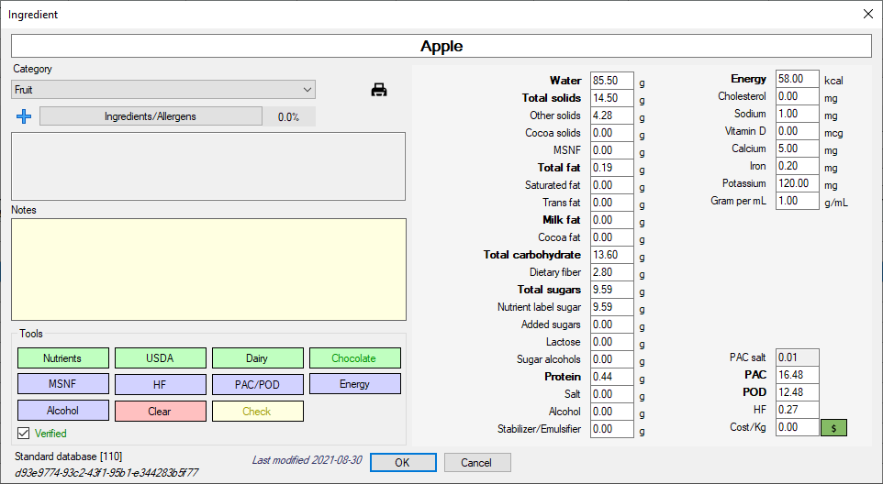

Overview
This is where you handle all the data in one ingredient.

Category
Select the ingredient category

Ingredients/Allergens
This is where you handle the sub ingredients and allergy information used in the nutrition label system. If you just make ice cream at home you don’t need to use this if you don’t want to.
The + button will add the ingredient name as a sub-ingredient.

Notes
A place to add notes to the ingredient

Tools

Clear
Clears all nutrient data

Nutrients
Set nutrient data from a nutrition label.

USDA
Set nutrient data from the USDA database

Dairy
Set nutrient data from a generalized dairy by setting the milk fat %. This method will calculate MSNF, Protein and Lactose etc. Don’t use this method if using the nutrition label system

MSNF
Calculates MSNF as the sum of Lactose and Protein

HF
Calculates the hardening factor using Cacao fat, Cacao solids, Other fat(calculated). The hardening factor acts as a negative PAC to control the hardening effects of chocolate and nut ingredients. It is the same as the negative PAC in the Corvitto book.

PAC/POD
PAC is the freezing point depression
POD is the relative sweetness
More info on PAC and POD in the Science section.
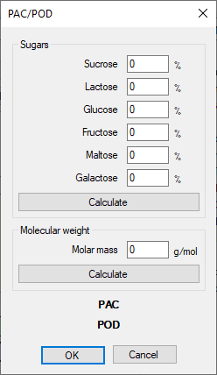
Tool for calculating PAC and/or POD using sugars or molecular weight. When using molecular weight, the POD cannot be calculated.

Energy
If adding an ingredient manually and not using the USDA or Label tools you can calculate the Energy from the nutrients.

Alcohol
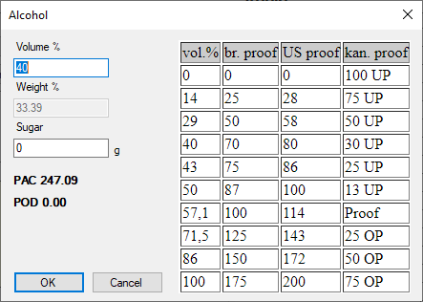
Normally alcohol is presented as Volume% or Proof. The ice cream calculator need the alcohol in weight% so this tool helps convert from Volume% to Weight%. I have also added a Sugar input if you have a sweet alcohol.

Check
Work in progress…This tool will analyze the nutrients and check for invalid input.

Chocolate
Work in progress…This tool will help adding chocolate ingredients.

Verified
When using the nutrition label system, you can use this checkbox to indicate that the ingredient is correct.

Data
Short descriptions of the nutrients and data. Some are self-explanatory.

Water
Water is 100-Total solids

Total solids
Total solids is everything that is not water. It is calculated as the sum of Other solids, Total fat, Total sugars, Stabilizers, Salt, Alcohol and Protein. When changing any of these the total solids will update accordingly and Water will also update.
If you change Total solids the Water will update and Other solids will update. Other solids acts as a balancing value with Total solids.
Note! This means you can not set both Total solids and Other Solids to any value you like as they are connected and if you change one the other will change to balance the equation.

Other solids
Other solids is a catch-all value that acts as a balance between Total solids and Water. Changing Total solids will also change Other solids to create balance.

Cocoa solids
Solids from chocolate

MSNF
Milk-Solids-Not-Fat, more info in the Science section.

Total fat
Total fat is the sum of Milk fat and Cacao fat and the calculated Other fat. Other fat acts in a similar way as Other solids to keep the Total fat balanced. So, if you have 30% Total fat and 10% Cacao fat and 10% Milk fat the Other fat is calculated to 30-10-10=10%

Saturated fat

Trans fat

Milk fat

Cocoa fat

Total carbohydrate
Should be entered including Dietary fiber. A Total carbs EU is calculated from this by removing Dietary fiber.

Dietary fiber

Total sugars

Nutrient label sugar
Some sugars like Maltodextrin have to handled specially. The nutrition label information for this sugar is different from the ice cream calculation. When we use this sugar to calculate freezing points etc., we need to use the Total sugars but when creating Nutrient labels Maltodextrin does not count as a sugar. So, normally Total sugars and Nutrient label sugar will be the same but for some ingredients you have to set different values to handle both calculations and correct nutrition labels.

Added sugars
In the US you have to specify Added sugars on the nutrition labels. Please refer to the USDA regulations for more information.

Lactose

Sugar alcohols
You might have to report Sugar alcohol or polyols if they exceed a certain amount.

Protein

Salt

Alcohol

Stabilizer/Emulsifier
We use this to track the amount of stabilizers and emulsifiers.
Note! It is not enough to set the Category to Stablizer for the system to keep track. You need to set this field for the calculator to know it is a stabilizer.

Energy

Cholesterol

Sodium

Vitamin D

Calcium

Iron

Potassium

Gram per mL
Work in progress. This value will be used in the Volume to weight tool if it is set.

PAC
The PAC from sugars and alcohol. Do not add PAC for Salt as this is calculated automatically.
Also important that the PAC and POD is for the full weight of the ingredient and not just the dry weight.
So, if the dry ingredient has PAC=100 and you have mixed this with water 50/50 you have to set the PAC=50.
Sometimes when you find PAC and POD values online it is for the dry ingredient but this calculator needs the PAC and POD for the whole ingredient including any water.

POD
Relative sweetness

HF
Hardening factor. Acts as a negative PAC value

Cost
Cost per Kg of the ingredient. The button will show a tool to input the cost in different ways.
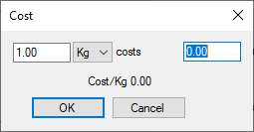
Tool to help calculate Cost per Kg

Print
Prints the ingredient data.

Balance
Balancing a recipe is what you do to make sure it has the properties you want it to have. You can either use this to develop your own recipe or to tweak/change an existing recipe. For example, if your ice cream has the perfect texture and softness but it is too sweet you can balance it to be less sweet while not changing the texture. You do this by changing some of the data like MSNF, PAC, POD, SOLIDS etc. by adding/removing/changing your ingredients.
Use the balance tool
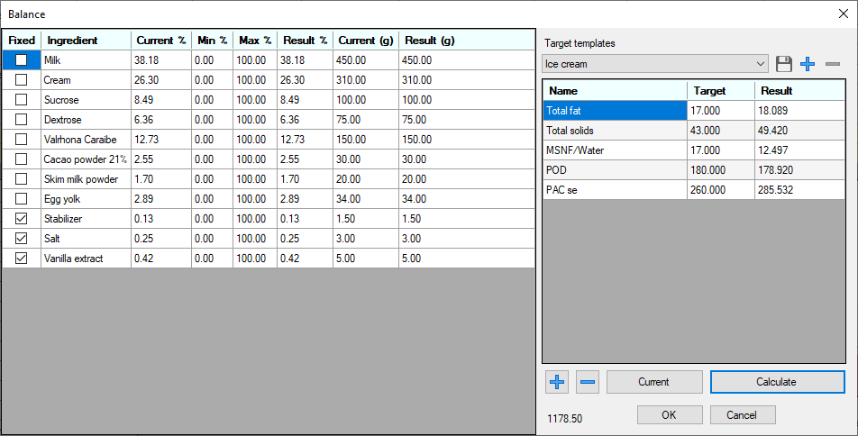
Set your target properties and press the Balance button. The balance calculations then tries to reach your target values.
You can select predefined balancing values in the drop-down list. You can also save your own presets by pressing the + button. Or saving by pressing the Save button.
You add target properties by pressing the + button below the list.
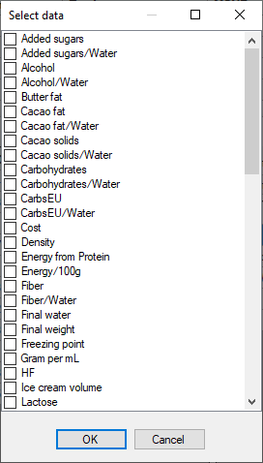
Then you set the target value in the grid.
By pressing the Current button all target values will be copied from the current recipe. This is useful if you just want to tweak a recipe a little.
The predefined target templates are very general and might not work for all ice cream or gelato recipes. For example if you make a chocolate ice cream the targets needs to change. The idea is for the user to create his/hers own target templates and not rely on the predefined templates.

Share
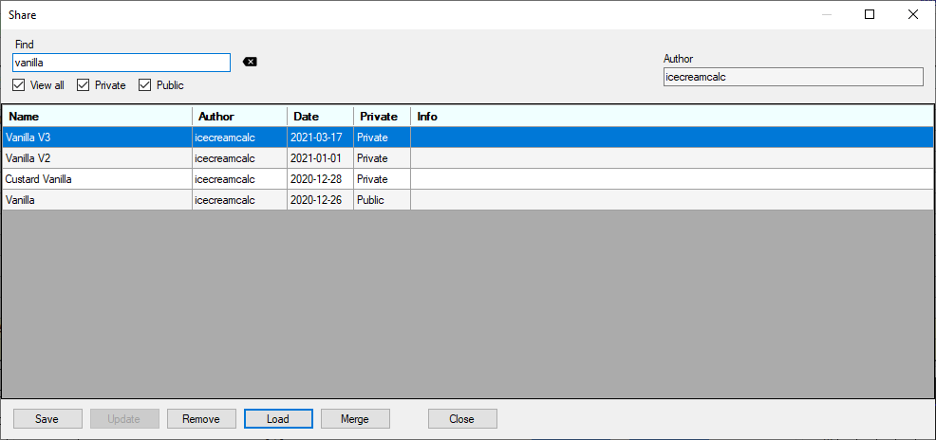
This is another way to save your recipe. Instead of saving the recipe in a file on your computer this method will save your recipe in an online database. You can select if your recipe should be public or private. If you select public it will be available to all users of icecreamcalc to open but only you can delete it or change it. If selecting private the recipe is only seen by you.
Before adding a recipe here you have to select an Author name. This is a unique name to identify you and your recipes. You can filter the recipes using the Find input.
Merge will add the selected recipe to your current recipe.

Nutrient Labels
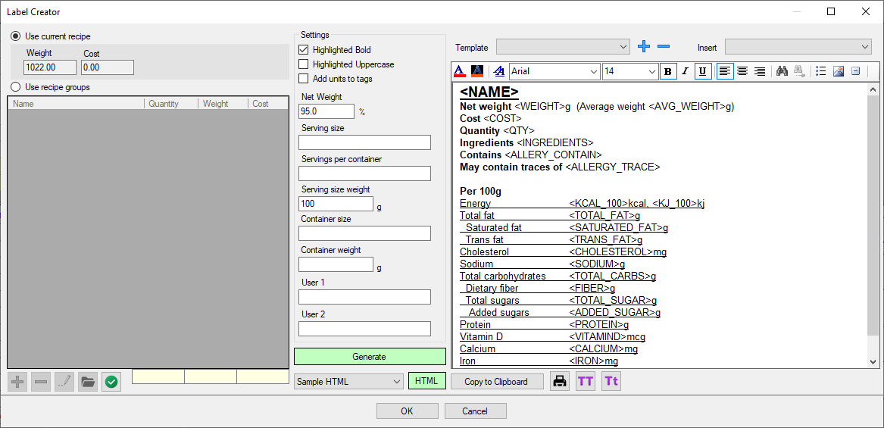

Overview
This is the nutrition label tool. Labels can be created using the editor or by using HTML. The system works by adding TAGS to the TEMPLATE and these tags are replaced by the calculated data.
The ingredients are merged and sorted and presented in the correct order.

Recipe Groups
A recipe group is a combination of multiple recipes and/or ingredients. This can be used for praline manufacturing or for handling add-ins in ice cream or gelato.

Settings
The only thing you need to set here is the Serving size weight and only if you are in the US. EU nutrition labels are always per 100g.

Template
You can create your own templates and select them from the list. A simple template could be to just add the TAG <INGREDIENTS> and you will get the list of ingredients. Important, the ingredients presented here must be set as sub-ingredients in each ingredient. So, the actual name of your ingredient is not automatically used! So, if you don’t see anything this might be the problem.

Generate
Press Generate to create the document and press the button again to switch back to edit mode.

html
You can also use HTML to generate labels. The default and only label is a US nutrition label. HTML also uses TAGS but they should be formatted with *TAG* instead of <TAG>. More info on request.

printing
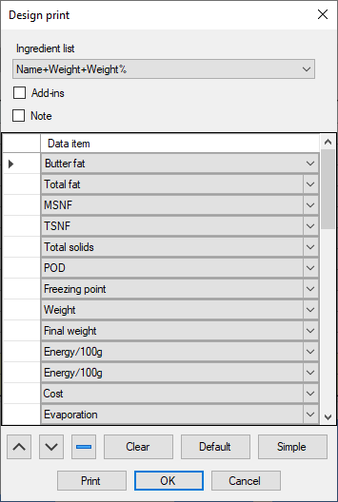
Here you can design and print your recipe.

milk/cream
Change the fat content of the milk and cream.
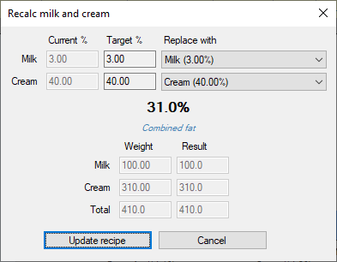
If you have milk and/or cream with a different fat content from your recipe you can change the fat percentages and still have the same combined fat content and same total weight. Just select a replacement press Update recipe to change.
This feature needs to know the milk and cream in the recipe. So, when pressing the button, a milk/cream selector comes up. Please just select the milk and cream in the drop-down boxes.
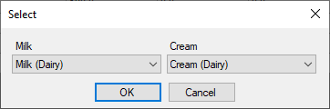

overrun
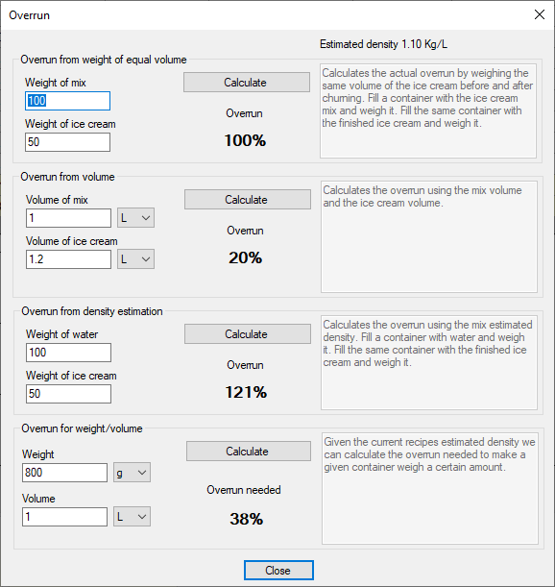
Tool for calculating overrun in different ways.

Settings
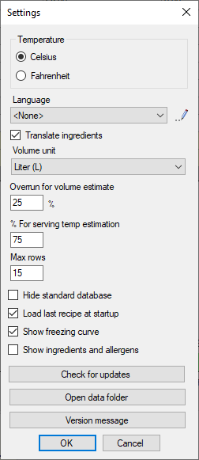
Temperature
Here you can select Celsius or Fahrenheit.
Language
Select the language. At the top of the box you can see how many texts are translated to the selected language. Contact icecreamcalc if you would like to contribute with the translations!
Translate ingredients
If this checkbox is checked then the ingredients are also translated if possible.
Volume unit
Select the unit you want to show the calculated volume of your ice cream.
Overrun for volume estimate
Set the overrun for volume estimation
Max rows
This controls the maximum number of rows to show for the ingredients in the main window. Depending on your screen resolution and how much space you like to use for panels you can change this value.
Hide standard database
If you only want to use your own ingredients you can check this box and the standard ingredients will not be loaded.
Load last recipe at startup
Check this to automatically reload the last recipe used. The filename will not be set so the recipe is not actually opened but all ingredients are added.
Show freezing curve
Turn on/off the freezing curve diagram in the main dialog.
Show ingredients and allergy
Turn on/off the ingredient and allergy list in the main dialog.
Check for updates
Check if a new version exists.
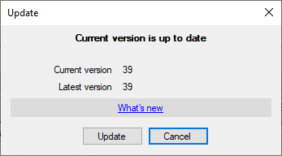

Customization
Many of the tables and charts etc. can be customized to fit your needs. Right-clicking in a table or chart will show a dropdown list with customization options.
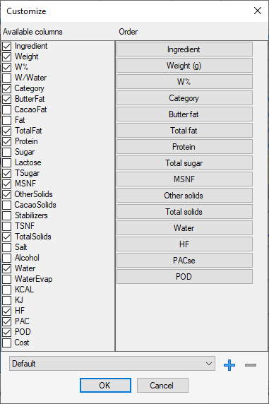
This is the customization of the ingredient table. On the left you can turn visibility on/off for the columns you want to view. On the right is the order of the columns. You can drag and drop do change the order.
At the bottom you can save your own user settings and these will be displayed when right clicking in the table.
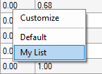

Nutrients and calculated data fields
A long list of all the data that is calculated. Ok, I haven’t written any information for these yet. I will do this upon request as most of them are self-explanatory.
- Added sugars
- Added sugars/Water
- Alcohol
- Alcohol/Water
- Butter fat
- Cacao fat
- Cacao fat/Water
- Cacao solids
- Cacao solids/Water
- Carbohydrates
- Carbohydrates/Water
- CarbsEU
- CarbsEU/Water
- Cost
- Density
- Energy from Protein
- Energy/100g
- Evaporation
- Evaporation %
- Fiber
- Fiber/Water
- Final water
- Final weight
- Freezing point
- Gram per mL
- HF
- HF@Serving temp
- Ice cream volume
- Lactose
- Lactose/Water
- Milk fat
- Milk fat/Water
- Mix volume
- MSNF
- MSNF/Water
- Other solids
- Other solids/Water
- PAC normalized
- PAC se
- PACtot
- PACtot normalized
- POD
- Polyols
- Polyols/Water
- Protein
- Protein/Water
- Salt
- Salt/Water
- Saturated fat
- Saturated fat/Water
- Saturated/Unsaturated
- Serving temp
- Stabilizers
- Stabilizers/Water
- Sugar
- Sugar/Water
- Total fat
- Total fat/Water
- Total solids
- Total solids/Water
- Total sugars
- Total sugars label
- Total sugars label/Water
- Total sugars/Water
- TotCost
- Trans fat
- Trans fat/Water
- TSNF
- TSNF/Water
- Unsaturated fat
- Unsaturated fat/Water
- Water
- Weight

Science

Overview
This will be a very short introduction to the science of ice cream. I refer you to the resources in the references for more information.

PAC
Potere Anti-Congelante
PAC or AFP or FPDF stands for Anti-Freezing Power and Freezing Point Depression Factor. This defines how much an ingredient lowers the freezing point of water. 100 PAC corresponds to 100 g of sucrose in 1000g of water. So, PAC is defined relative to sucrose. The ‘se’ stands for sucrose equivalent.

POD
Potere Dolcificante, relative sweetness compared to sucrose
How sweet is an ingredient compared to sucrose. Including lactose from milk products.

Freezing Point

Hardening Factor
Hardening factor. Some ingredients harden the ice cream more than others. Normally used for ingredients in the chocolate and nuts categories. The HF is calculated as Cacao fat*0.9 + Other solids*1.8+OtherFat*1.4. The HF acts as a negative PAC value. The reason I don’t use negative PAC in the same way as for example Corvitto is that these ingredients harden the ice cream but they don’t generally change the freezing point of the ice cream. It makes more sense to separate this into its own variable instead of manipulating the PAC.

Freezing Curve
The freezing curve and hardness curve are used to estimate the hardness of the ice cream at a specific temperature. My method uses freezing point data of sucrose solutions and a regression calculation. There are other methods to calculate this curve and this is still something I am investigating.

Sugars
Sugar is a generic name for sweet tasting carbohydrates. Sugar can be simple sugars monosaccharides or compound sugars disaccharides. Longer chains of monosaccharides polysaccharides are not counted as sugars. The most common sugar is sucrose (regular sugar, table sugar, granulated sugar) a disaccharide composed of glucose and fructose. Sugar is very important in ice cream. It makes the ice cream sweet; it gives the ice cream body and it controls the hardness of the ice cream.
SUCROSE – disaccharide
This is of course the most well-known sugar and when we say sugar this is usually what we mean. Most ice cream recipes only use sucrose. To take your ice cream to the next level you should start combining sucrose with at least one more sugar to be able to control the sweetness and hardness better. I recommend dextrose but glucose syrup or honey also work well.
BROWN SUGARS
Brown sugars are sucrose with some amount of molasses. It can be unrefined or partially refined sugar or more commonly refined white sugar with added molasses. When using brown sugars in ice cream you should check the sugar and water content and add that appropriately. The molasses adds flavor to the sugar.
DEXTROSE – monosaccharide
Dextrose is actually glucose. Glucose comes in two forms D-Glucose and L-Glucose. The D-Glucose is called dextrose monohydrate or simply dextrose. This is my favorite sugar to use together with sucrose when making ice cream. It is less sweet than sucrose but has almost double the freezing point depression. By combining sucrose and dextrose you can control the sweetness and hardness of your ice cream.
FRUCTOSE – monosaccharide
This is the sugar found in many plants and fruits. It is much sweeter than sucrose and has almost twice the freezing point depression. I use this sometimes in combination with sucrose and dextrose especially when I want to lower the total solids and maintain the sweetness.
LACTOSE – disaccharide
Lactose is the sugar in milk and it has very low sweetness.
STARCH BASED SUGARS – DE Dextrose Equivalent
Maltodextrin, glucose syrup and glucose powders are all starch-based sugars consisting of chains of D-glucose molecules.
They are all characterized by a DE number. The DE stands for Dextrose Equivalent and indicates the amount of reducing sugars. The easiest way to think of this is the lower the DE number the less sweet the sugar is.
MALTODEXTRIN
Maltodextrin is a starch-based polysaccharide consisting of different length chains of glucose. It has a DE of 3-20. Maltodextrin has very little sweetness and is mainly used as a bulking agent. In ice cream it can be used for sorbets for example to increase the total solids.
GLUCOSE SYRUPS
Glucose syrups have a DE>20. The most common glucose syrup has DE42. Glucose syrup is about half as sweet as sugar and approximately 80% of the anti-freezing power. Glucose syrup also has 20% water.
GLUCOSE POWDER, ATOMISED GLUCOSE
This is glucose in powder form and also defined by its DE number.
INVERT SUGAR – monosaccharides
Invert sugar is a mix of fructose and glucose. It is made by heating sucrose in water with a catalyst to break the bond between the fructose and glucose and “invert” the sugar.
HONEY
Honey is a natural product but it is similar to invert sugar. It’s great for ice cream and adds its own honey flavor.
SYRUPS
There are literally hundreds of different syrups out there and I wouldn’t know where to start. If using a syrup try to find out how sweet it is compared to sucrose or even better what different sugars it is made up of.

Stabilizers
Most of my recipes use some kind of stabilizers. I get a lot of questions what I use and what can be used instead. When a recipe just includes the ingredient Stabilizer, I have usually used a commercial stabilizer blend. Sometimes I have noted the exact stabilizers or blend I have used. If you don’t have the stabilizers I use don’t worry. There are plenty of alternatives. First you can simply skip adding stabilizers at all. This might affect the quality of the ice cream a little but if you don’t intend to store the ice cream or take it in and out of the freezer multiple times you will be fine. The second option is to replace it with what you have available or can easily source. I always give the weight of the stabilizer I used. If you replace it you might have to use some other weight. If you use a commercial blend check the instructions on the package. Also, one tip is to start at the low end of the recommended dosage. Anyway, here are some stabilizer options. You will find more info for each stabilizer below.
All recommendations are for a 1000g mix.
When using gums you need to get a high precision scale. They are quite cheap and can be found on Amazon for example.
You want to look for something like a jewelry pocket scale 0-500g with a 0.01g accuracy.
Tip! When adding individual stabilizers aim for 0.25% of the water weight as a good start (approx. 0.12% of total weight)
Tip! When adding stabilizers, you must always mix them with the sugar and/or other dry ingredients before adding them to the liquid. When adding you must also whisk vigorously or even better use a blender or a stick blender.
Gelatin
This is a great stabilizer and it is readily available. Use one sheet or 2g.
Gelatin + Xanthan gum
Xanthan gum is also available in most stores. Use 1g gelatin and 0.3g Xanthan. Be careful when measuring Xanthan, too much and the ice cream will get a slimy texture.
Locust Bean Gum (LBG)
This is one of the best stabilizers to reduce ice crystal size and protect against the heat-thaw cycle. If you only want to use one stabilizer this is a good candidate. Use approx. 1g.
Guar Gum
Another good stabilizer that gives the ice cream body. Not as good as LBG to suppress ice crystals. Use 0.5g-1g if used alone. Too much and the ice cream will become chewy.
LBG+Guar
This is a good blend use 0.8g LBG + 0.4g Guar.
LBG+Guar+Lambda Carrageenan
This is a very good general blend. LBG for ice crystals, Guar for body and L-Carrageenan for a smooth melt.
Use 0.8g LBG + 0.4g Guar + 0.2g L-Carrageenan. L-Carrageenan helps with what is called wheying off. This is when water separates from the ice cream when it melts. So, L-Carrageenan gives a smoother melt.
For mixes that is not heated
If the mix is not heated you need to use stabilizers that hydrates cold. I use a commercial blend called Cremodan 500 Cold that I like very much. If you blend your own stabilizers, you can use Guar and Xanthan and L-Carrageenan but not LBG.
Another stabilizer is Carboxymethyl Cellulose or CMC.
CMC+Guar+L-Carrageenan
Try 0.5g CMC + 0.4g Guar + 0.2g L-Carrageenan
Stabilizers in Ice Cream
Stabilizers are hydrocolloids, which means that when they disperse into a liquid, they bind to the water molecules, thereby reducing their movement. The primary purposes for using stabilizers in ice cream are.
• Make the ice cream smoother by reducing the size of the ice crystals.
• Increase mix viscosity.
• Resist temperature fluctuations.
• Control shape retention during melting.
• Control shrinkage.
• Control wheying off.
• Help suspend flavoring particles.
• Prolong storage time.
Guar gum (E412)
The guar or cluster bean, with the botanical name Cyamopsis tetragonoloba, is an annual legume. It is also known as gavar, gawar, or guvar bean. It has been grown in India and Pakistan for centuries.
• Hydrates cold.
• Adds body and viscosity.
• Provides heat-shock resistance.
Locust bean gum (LBG, Carob bean gum) (E410)
Locust bean gum is obtained from the beans of the tree Ceratonia siliqua, grown mostly in the Mediterranean area.
• Must be heated to 85C/185F for full hydration.
• One of the best to reduces ice crystal size.
• Adds medium viscosity.
• Adds superior heat-shock resistance.
• Does not produce any taste or ﬂavor-masking properties.
Carrageenan (E407)
This stabilizer was originally derived from red algae called Chondus crispus. The major sources of this gum are now the two tropical red seaweeds, Eucheuma cottonii and E. spinosum.
• Mainly used to control wheying off.
• Hydrates cold.
Xanthan gum (E415)
This bacterial exopolysaccharide is obtained by the growth of Xanthomonas campestris in culture. Its blend with guar gum and/or locust bean gum makes an effective stabilizer for ice cream, ice milk, sherbet, and water ices.
• Hydrates cold.
• PH resistant.
• Easy to get hold of.
• Not the best at ice crystal suppression.
Gelatin (E441)
A common stabilizer before the introduction of gums. Made from animal collagen.
• Hydrates at 50C/122F.
• Very good ice crystal suppression.
• Requires long aging time to fully hydrate.
• Easy to get hold of.
Sodium Carboxymethyl Cellulose CMC (E466)
This chemically modiﬁed natural gum is a linear, long-chain, water-soluble, and anionic polysaccharide. CMC forms weak gels by itself but gels well in combination with carrageenan, locust bean gum, or guar gum.
• Hydrates cold.
• Adds body and chewiness.
• Very good ice crystal suppression.
Corn starch
Info needed…(I never use starches)
Tapioca starch
Info needed…(I never use starches)

System Requirements
Windows
.NET 4.5
64-bit OS

Installation
Ice Cream Calculator is freeware and as such is not a trusted application yet anyway. When installing and even downloading the Windows security systems and different virus protection software might not like this. So, be advised that you might get all kinds of warnings and errors. Sorry for this!

References
https://www.amazon.com/Ice-Cream-H-Douglas-Goff/dp/1461460956
https://www.booksforchefs.com/en/professional-ice-cream-books/234-secrets-of-ice-cream-angelo-corvitto.html
https://www.hellomynameisicecream.com/
https://under-belly.org/category/ice-cream/
http://icecreamscience.com/
https://www.dairyscience.info/index.php/ice-cream.html
https://www.uoguelph.ca/foodscience/book-page/ice-cream-ebook
https://www.dreamscoops.com/tips-and-tricks/troubleshooting-homemade-ice-cream/
https://www.dreamscoops.com/ice-cream-science/
https://medium.com/@gelatologist
https://www.nutritionvalue.org/

